**SECTION GB**

**FUEL OIL SYSTEM**

GENERAL DESCRIPTION

Fuel is supplied from a daily service tank (l)(Fig GB.l) via isolating valve (2) to a gear type fuel feed pump (8) mounted at the free-end of 'B' bank fuel injection pump cambox and driven from the pump camshaft by means of a bevel gear (see Section GC). The system is pressurised by the pump, a by-pass type relief valve (12) incorporated in the pump relieving fuel in excess of system requirements from the delivery to the suction side of the pump.

From the feed pump, fuel is supplied to a coalescer filter (13) which removes foreign matter and extracts any water in the fuel. Fuel flows from the coalescer filter to a duplex fuel oil filter (14) and then to the first stage of a two stage fuel reservoir (3). At this point, any air trapped in the fuel separates out and is passed to the second stage of the reservoir via a permanent bleed from where it is returned to the tank by an air bleed drilling in the relief valve (see Section GD).

From the reservoir first stage, fuel is passed to lower fuel pump gallery rails (4) and then to fuel injection pumps (5). Fuel in excess of pump requirements is returned to the second stage of the reservoir via upper fuel pump gallery rails (7). A relief valve incorporated in the top of the reservoir controls the pressure in the system, excess fuel being relieved back to the daily service tank. Fuel injectors (6) drain to the top of the fuel reservoir via a pipe and vertical non return valve.

A hand priming pump (10), isolating valve (9) and non return valve (11) are included in the system, and so arranged that by opening the isolating valve immediately before the hand priming pump, fuel may be pumped around the system, by-passing the fuel lift pump, and allowing the filters and reservoir to be primed with fuel before first time starting or if the system has been disturbed. The isolating valve must be closed before starting the engine. The non return valve stops pressurised fuel leaking back to the hand priming pump while the engine is running.

As a safety feature, the high pressure pipe lines between the fuel-injection pumps and the fuel injectors are ’sheathed’ (see Section GJ). In the event of a failure of one of the injection pipes the fuel is piped away to a catchment tank fitted with an alarm.

Key To Numbers

1. Daily service tank
2. Isolating valve
3. Fuel oil reservoir
4. Lower fuel pump gallery rails
5. Fuel injection pump
6. Fuel injector
7. Upper fuel pump gallery rails
8. Fuel feed pump
9. Isolating valve
10. Hand priming pump
11. Non return valve
12. Fuel pump relief valve
13. Coalescer filter
14. Duplex fuel oil filter
15. Drain pipe for sheathed fuel injection pipes

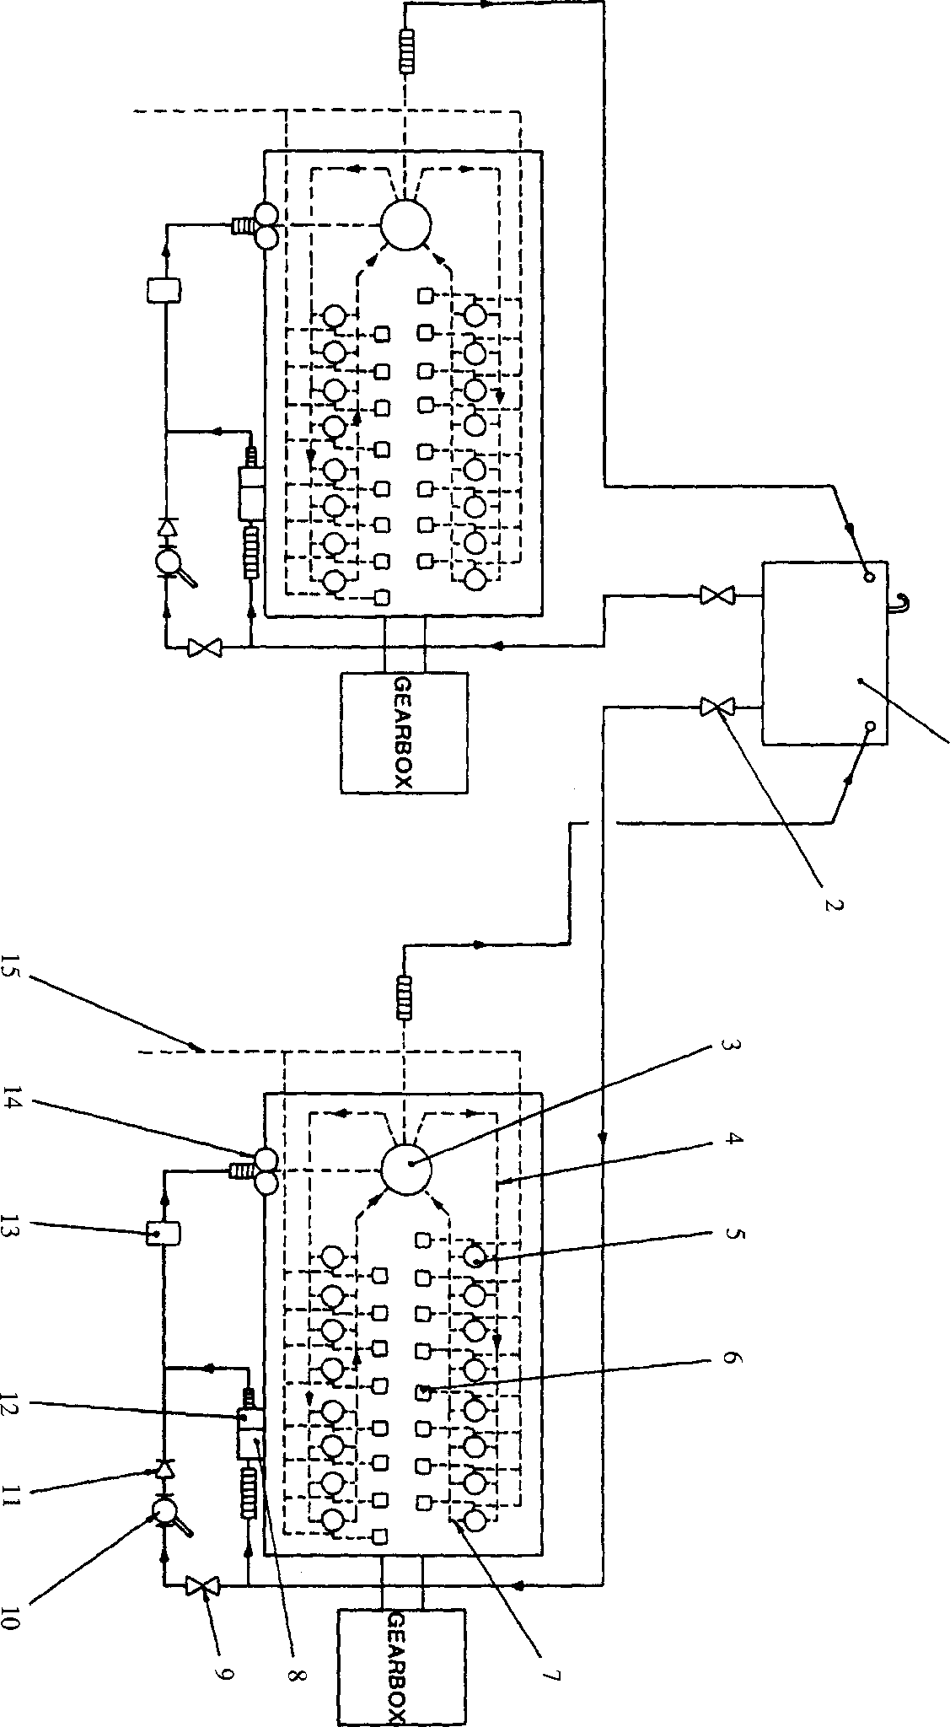

**SPD00467**

Fig GB.l Schematic arrangement of fuel oil system